RESUME
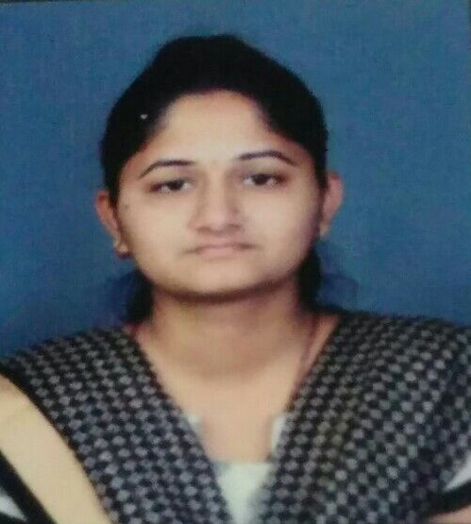
UTKARSHA M. CHOUGULE
A/t post:-Karnur, Tal.-Kagal, Dist.-Kolhapur, Pin code – 416216
Mobile :-9923210354
E-mail id: utkarsha150@gmail.com
Branch: Electronics and Telecommunication Engineering

OBJECTIVE
I am seeking employment with a company where I can use my talents and skills to grow and expand the company.

ACADEMIC CURICULUM
Exam | Name of Institution | Board | Year of passing | Percentage
BE | Dhananjay Mahadik Group of Institute vikaswadi,kagal | Shivaji University, Kolhapur | 2017 | 71.07
TE | Dhananjay Mahadik Group of Institute vikaswadi,kagal | Shivaji University, Kolhapur | 2015 | 62.94
SE | Dhananjay Mahadik Group of Institute vikaswadi, kagal | Shivaji University, Kolhapur | 2014 | 58.75
FE | Dhananjay Mahadik Group of Institute vikaswadi, kagal | Shivaji University, Kolhapur | 2013 | 56.59
HSC | Shrii Shahu High school and Junior college, kagal | Maharashtra State Board, Pune | 2012 | 71.50
SSC | K.B.P. High School, Bagani | Maharashtra State Board, Pune | 2010 | 92

HIGHLIGHTS
- Participated in INTERNATIONAL CONFERENCE OF RECENT INNOVATIONS which was in BIMAT 2016 based on project paper of the DATA TRANSFER BETWEEN TWO PENDRIVES WITHOUT PC.
- Participated in PAPER PRESENTATION competition of the project paper DATA TRANSFER BETWEEN TWO PENDRIVES WITHOUT PC at Sharad Institute of Technology College of engineering, Yadrav in 2016.
- Participated in TEXAS INSTRUMENTS competition which was in BIMAT 2014 and 2015.
- Participated in WORKSHOP OF ARDUINO in Ashokrao Mane Polytechnic, Vathar in 2014.

- Worked as event co-ordinator (Association of electronic and telecommunication engineering) on National level technical event Xecute 2K15 which was in BIMAT.
- Campaign in New Polytechnic, Uchagaon and Dr.Bapuji Salunkhe Polytechnic, Kolhapur for Technocracy event 2k14.
- Campaign in Ashokrao Mane Polytechnic, Vathar for National Level Workshop on Advanced Trends in Embedded Systems which was in BIMAT 2014.
- Industrial training visit in Ratnagiri for AKASHAWANI KENDRA office at 2014 and in kagal for INDO COUNT DEPARTMENNT OF ONIDA TV Company at 2014.
- Training of PLC AND SCADA in BIMAT College.
- Industrial training visit in B channel office, Kolhapur 2015.
- Participated in sports and secured 1st RANK IN TRESURE HUNT competition which was in BIMAT 2016.
- Participated in sports and secured 1st RANK IN TUG OF WAR competition which was in BIMAT 2014, and Runner up in 2015, 2016.
- Participated in National Level Technical Event which was in BIMAT 2k12, KIT 2K13, RIT 2k13, KIT 2k14, DOT Kolhapur 2k14 and State level competition at BIMAT 2k14.
- In school secured 1st RANK in 1st to 7th std and 9th std, 3rd in 8th std, 2nd in 10th std.
SOFTWARE AND HARDWARE SKILL
Programming Language: - C
Software work on : - MATLAB (Simulink), ORCAD 9.1, Keil C3, C4, Proteus, Xilinx 8.11.
Basic knowledge of : - Telecommunication, Microprocessor, 8051, Embedded system.
PROJECT DEATILS
Mega project: Data transfer between two pen drives without pc:
Project work on: The main purpose of project is to transfer data between two pen drives without pc.
Duration 1 year
Environment Microcontroller, host controller, keil c 4,
Team size 3
Mini project: Digital voltmeter using Microcontroller:
Project work on: The main purpose of our project is to measure voltage using the controller.
Duration 6 Months
Environment Microcontroller
Team size 3
FIELD OF INTERSET
Telecommunication
Electronics and semiconductor

STRENGTHS
Hardworking
Patience
Time punctual
Playing with software
PERSONAL DEATILS
Date of Birth : 10 July 1994
Father’s Name : Mahavir Kallapa Chougule
Sex’s : Female
Marital status : Single.
DECALRATION
I hereby declare that all the information furnished above is true to the best of my knowledge and belief.
Place:
Date: (UTKARSHA M.CHOUGULE)

